[Destroying the Internet (BGP routers) EP 1 // BGP Python scapy DoS script](https://www.youtube.com/watch?v=39DGVpMt7eQ)

Internetworking

BGP attacks can take down internetwork spots

Topology

**BGP uses TCP port 179**

Layer2 relationship is NOT important in this scenario

Kali sniffing packets from BGP routers => sending back to Network

BGP router to BGP router = **TCP unicast**

**Switch by default would NOT forward traffic to Kali**

Thus, we need to use 'Wiretaps'

The port

It does NOT allow traffic to be sent back into the network

Then sniff the traffic and monitor the traffic out of that port

Problem of Wiretaps

yet, Wiretaps do NOT allow us to send traffic back into the network

**We wanna monitor traffic between BGP routers,**

**receive the traffic & then manipulate the packets,**

**then send manipulated packets back into the network,**

**to get BGP routers do things for us**

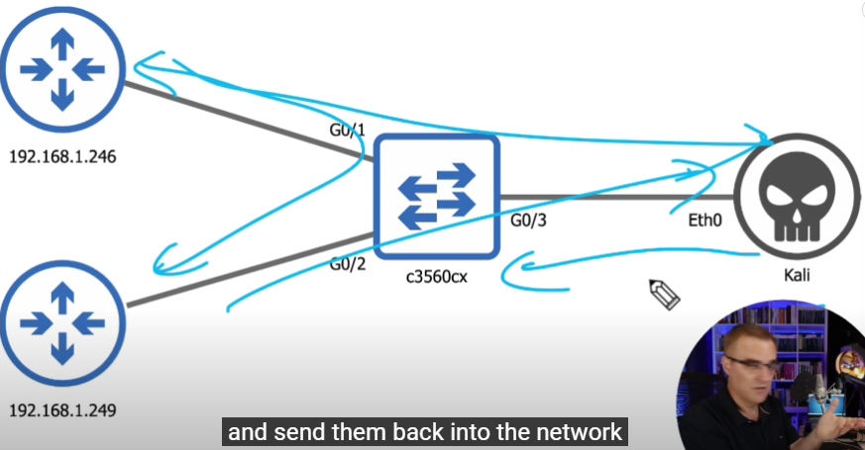

In order to remove Routes from Switch to BGP Router 192.168.1.249

We must pretend our Kali to be BGP router 192.168.1.246 to send packets to BGP router 192.168.1.249 (Internet Access),

and get 192.168.1.249 to remove Routes from its routing tables

**Set-up of Port Mirroring to mirror traffic from BGP Router 192.168.1.246 via Gi0/1 to Switch c3560cx then to our Kali, and**

**configure Gi0/3 to NOT only just mirror traffic, but also receive traffic**

**Connecting to c3560cx Switch**

sh run | include monitor

**Source of traffic from BGP Router 192.168.1.246 to Switch c3560cx is via Gi0/1**

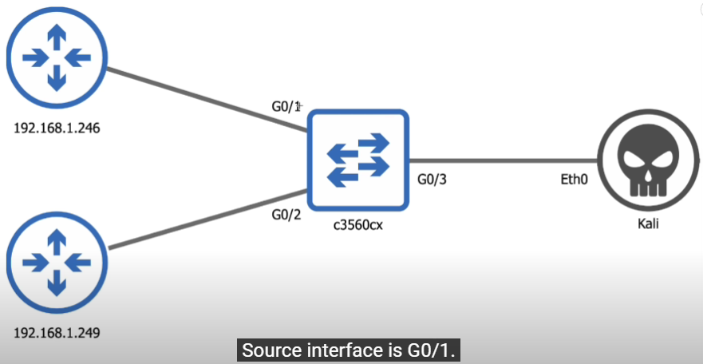

**Network traffic between Switch c3560cx and Kali is via Gi0/3**

**\*\*\* We need access to the Switch to basically tap the network \*\*\***

**\*\*\* or We need a Hub/Wiretap to see traffic between BGP Routers \*\*\***

**\*\*\* To start intercepting traffic between Switch & BGP Routers**

**We Bridge Kali's network adapter on any Devices (Windows?) connecting to the Switch that connects to any BGP routers \*\*\***

**Now, we can start injecting traffic to the network**

1st script = bgp-dos-reset-neighbors.py to Reset the neighbor relationships between BGP routers

2nd script = bgp-remove-route.py to Remove routes out of the routing table

3rd script = bgp-add-fake-routes.py to Inject fake routes into BGP routing table

1st script =

**bgp-dos-reset-neighbors.py**

Reset the neighbor relationships between BGP routers

**BGP Hacking Topology**

# Let's say there's a computer (compA) connects to a Switch

# in which, that Switch also connects to some BGP Routers

# Once you've connected your laptop (Kali VM host) to compA using LAN cables

# You 'bridge' your Kali's network adapter to compA NIC

# Asking for a BGP Router IP:

# Use Ettercap & Wireshark to sniff all the devices in the network

# Find out all BGP Routers IP

# Enter 1 BPG Router IP for further sniffing

bgp_IP = input('Enter BGP Router dst IP [192.168.1.249]: ')

# This captures 1 packets from Switch to Internet BGP Router

# In order to make this BGP hack work

**# We need to know Src & Dst ports**

# BGP uses TCP port 179

# Yet this depends on which BGP Router initiates the session

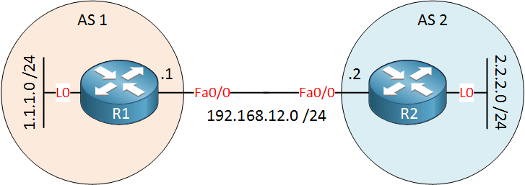

# Assume we have 2 BGP Routers

# BGP Router A (left) & BGP Router B (right)

# If BGP Router A (left) initiates the session to BGP Router B (right)

# BGP Router B (right) has dstPort = 179 on itself

# If BGP Router B (right) initiates the session to BGP Router A (left)

# BGP Router A (left) has dstPort = 179 on itself

**# Simply saying:**

**# The BGP Router that initiates Session to another BGP Router**

**# has a randomPort, while the BGP Router that receives initiation of a Session has dstPort**